**Department of Computer Engineering**

**Faculty of Science and Technology**

**A**

**Preliminary Project Report on**

**IoT-Based Energy Optimization**

**Submitted to Vishwakarma University, Pune**

**In the partial fulfilment for the award of the degree of**

**BACHELOR OF TECHNOLOGY**

**IN**

**COMPUTER ENGINEERING**

**By**

**Atharva Zanjurne (202200777)**

**Mohit Patel (202200749)**

**Anagha Patil (202200706)**

**Vineet Ravi Hadli (202200632)**

**Kamlesh Choudhary (202200836)**

**UNDER THE GUIDANCE OF**

**Dr. Reshma Pise**

**Academic Year**

**2024-2025**

**CERTIFICATE**

This is to certify that the project report entitled

**IoT-Based Energy Optimization**

**Atharva Zanjurne (202200777)**

**Mohit Patel (202200749)**

**Anagha Patil (202200706)**

**Vineet Ravi Hadli (202200632)**

**Kamlesh Choudhary (202200836)**

is a bonafide work carried out by them under the supervision of **Dr. Reshma Pise** and it is approved for the partial fulfilment of the requirement of Vishwakarma University for the award of the Degree of Bachelor of Technology in Computer Engineering.

This project report has not been earlier submitted to any other Institute or University for the award of any degree or diploma.

**Dr. Reshma Pise Dr. Reshma Pise**

Internal Guide, Head of Department,

Department of Computer Engineering Department of Computer Engineering

**Dr. Kailash Patil**

Dean,

Department of Computer Engineering

External Examiner:

Place:

Date:

**DECLARATION**

We here by declare that this submission is our own work and that, to the best of our knowledge and belief, it contains no material previously published or written by another person nor material which has been accepted for the award of any other degree or diploma of the university or other institute of higher learning, except where due acknowledgement has been made in the text.

**Place: Date:**

**Signature:**

|  |  |  |
| --- | --- | --- |
| Group Member Roll No. | Group Member Name | Signature |
| 54 | **Atharva Zanjurne** |  |
| 51 | **Mohit Patel** |  |
| 46 | **Anagha Patil** |  |
| 39 | **Vineet Hadli** |  |
| 62 | **Kamlesh Choudhary** |  |

**ACKNOWLEDGEMENT**

We would like to take this opportunity to express our heartfelt gratitude to everyone who has supported and guided us during the ongoing development of our project titled **“IoT-Based Energy Optimization.”**

We are especially thankful to our project guide, **Prof. Reshma Pise**, for her continuous encouragement, valuable insights, and technical guidance. Her support has been instrumental in shaping the direction of our work and helping us navigate various phases of the project.

We also express our sincere thanks to the **Department of Computer Engineering, Vishwakarma University, Pune**, for providing us with the necessary resources and a motivating academic environment that fosters innovation and learning.

We would like to acknowledge the contributions of our teammates, whose collaborative efforts and shared commitment have laid a strong foundation for this project.

While the project is still in progress, the knowledge and experience we have gained so far have been highly enriching. We look forward to the successful completion of this work with the same level of dedication and teamwork.

**Name of Students:**

**Atharva Zanjurne**

**Mohit Patel**

**Anagha Patil**

**Vineet Ravi Hadli**

**Kamlesh Choudhary**

**ABSTRACT**

Our project aims to develop an IoT-based system that intelligently manages classroom electrical devices, such as lights, fans, and projectors, by detecting human presence. The system ensures energy efficiency by turning off all devices when no human is present and selectively controlling them based on real-time occupancy.

The system comprises an ESP32 microcontroller for overall control and an ESP32-CAM module integrated with a machine learning algorithm to accurately detect humans while filtering out other living beings. Additionally, a laser sensor determines the precise location of individuals within the classroom, enabling a targeted approach—keeping only the lights and fans directly above the detected occupants switched on while turning off unused devices.

**Keywords:**

Internet of Things (IoT)

Smart Classroom

Human Detection

Machine Learning (ML)

ESP32 Microcontroller

ESP32-CAM

Energy Optimization

Automation Systems

Laser Sensor

Occupancy-Based Control

Embedded Systems

Sustainable Computing

Edge Computing

Computer Vision

**TABLE OF CONTENTS**

|  |  |
| --- | --- |
| CERTIFICATE | I |
| DECLARATION | II |
| ACKNOWLEDGEMENT | III |
| ABSTRACT | IV |
| TABLE OF CONTENTS | V |
| LIST OF FIGURES | VII |
| LIST OF TABLES | VIII |

|  |  |  |  |  |
| --- | --- | --- | --- | --- |
| **CHAPTERS** | | | **TITLE** | **Page No.** |
| **1.** |  |  | **INTRODUCTION** |  |
|  | 1.1 |  | Motivation | 9 |
|  | 1.2 |  | Need | 10 |
| **2.** |  |  | **LITERATURE SURVEY** |  |
|  | 2.1 |  | Literature survey | 11 |
| **3.** |  |  | **PROBLEM STATEMENT** |  |
|  | 3.1 |  | Objectives | 15 |
|  | 3.2 |  | Feasibility Study | 16 |
| **4.** |  |  | **PROJECT REQUIREMENTS** |  |
|  | 4.1 |  | Software Requirements. | 18 |
|  | 4.2 |  | Hardware Requirements | 18 |
| **5.** |  |  | **SYSTEM ANALYSIS OF PROPOSED ARCHITECTURE** |  |
|  | 5.1 |  | System Architecture Diagram | 19 |
|  | 5.2 |  | Data Flow Diagrams | 19 |
|  | 5.3 |  | UML Diagrams |  |
|  |  | 5.3.1 | Use case Diagram | 20 |
|  |  | 5.3.2 | Activity Diagram | 21 |
|  |  | 5.3.3 | Sequence Diagram | 22 |
|  |  | 5.3.4 | State Diagram | 23 |
|  |  | 5.3.5 | Deployment Diagram | 24 |
|  |  | 5.3.6 | Component Diagram | 24 |
|  |  | 5.3.7 | Class Diagram | 24 |
| **6.** |  |  | **IMPLEMENTATION** |  |
|  | 6.1 |  | Methodology | 26 |
|  | 6.2 |  | System Overview | 27 |
| **7.** |  |  | **PROJECT PLAN** | 29 |
| **8.** |  |  | **CONCLUSION** | 31 |
| **9** |  |  | **REFERENCES** | 32 |

**Introduction:**

**Motivation:**

Energy wastage due to unnecessary operation of electrical appliances like lights and fans is a common issue in various environments—classrooms, offices, libraries, meeting halls, and more. This project proposes a Smart Energy Optimization System that leverages Internet of Things (IoT) devices and AI-based human detection to dynamically manage energy consumption in any indoor setting.

The system uses ESP32 and ESP32-CAM microcontrollers, along with the VL53L0X laser distance sensor, to detect the presence and location of people in real time. The ESP32-CAM, supported by a lightweight AI model such as Tiny-CSS, differentiates between humans and non-human objects. Based on the detected locations, the system intelligently determines which lights and fans need to be active and switches off all others, significantly minimizing power usage.

The user interface is built using ReactJS, offering real-time monitoring and control, while the backend is powered by Node.js, handling communication between devices, processing sensor data, and managing AI inference. This distributed, scalable solution enables smarter energy usage across a wide variety of settings, promoting automation, efficiency, and sustainability.

**Need:**

Conventional lighting and ventilation systems operate with little regard for actual human presence or location.

This often leads to:

* Significant energy wastage, especially in large or sparsely occupied areas.
* Increased operational costs due to overuse of electrical systems.
* Inefficient environmental management, causing discomfort or reduced focus in learning or workspaces.

There is a clear and growing need for smart, context-aware systems that can:

Automatically detect and localize human presence.

Activate only the necessary electrical appliances based on proximity.

Be deployed easily in a wide range of indoor environments—not limited to classrooms.

This project addresses that need by combining cost-effective hardware, real-time AI detection, and IoT-based automation to ensure that energy is used only where and when needed.

By doing so, it supports:

Sustainability initiatives and reduced carbon footprint.

Cost savings for institutions, businesses, and homes.

Smart infrastructure development aligned with the principles of smart cities and green buildings.

This system represents a practical step forward in creating intelligent spaces that are both energy-conscious and responsive to human activity

**Literature Survey:**

**Introduction:**

With the growing need for sustainable energy solutions, optimizing energy usage in buildings—particularly in shared spaces like classrooms, offices, and libraries—has become critical. Traditional manual control systems and even basic automation using motion sensors often fail to adapt to real-time human presence and precise location. This leads to unnecessary energy consumption when lights and fans remain switched on without direct utility. Leveraging IoT, distance sensors, and lightweight AI models enables intelligent energy optimization based on the human presence and their spatial position in a room. This literature survey presents an in-depth review of existing solutions across IoT-based automation, human detection, localization, and intelligent control systems to identify gaps and establish the foundation for the proposed work.

**2.2 Review of Related Work**

**2.2.1 IoT in Energy Management**

Patel et al. (2020) implemented a basic automation system using Arduino and Passive Infrared (PIR) sensors to detect movement and switch lights on/off. While simple and low-cost, this setup lacked the ability to distinguish between humans and inanimate objects or track user location.

Ghosh et al. (2019) developed a smart classroom system where lights and fans were controlled through PIR motion sensors and timers. However, the system would activate all appliances when any presence was detected—irrespective of the actual number or position of users—leading to inefficient energy use.

Mehta et al. (2021) proposed an IoT energy monitoring system using ESP8266 microcontrollers that recorded usage data to optimize energy patterns. Though efficient in analytics, it didn’t provide real-time automation or human-aware controls.

These studies show that while IoT plays a crucial role in automation, there remains a gap in dynamic, real-time control based on localized human presence.

**2.2.2 Human Detection Using AI on Edge Devices**

Redmon et al. (2016) introduced YOLO (You Only Look Once), a deep learning-based object detection framework capable of identifying multiple classes in real time. Its accuracy and speed were groundbreaking, but its large model size made it unsuitable for embedded edge devices.

Tiny-YOLO and Tiny-CNN, developed as lightweight alternatives, are specifically optimized for devices like Raspberry Pi, Jetson Nano, and ESP32-CAM. These models provide reduced accuracy compared to full-scale YOLO but are fast enough for real-time deployment on microcontrollers.

Although, Tiny YOLO is too heavy for real-time detection on ESP32-CAM unless optimized further.

Tiny CNN is ideal if you’re building a model from scratch for basic classification.

Zhang et al. (2021) deployed Tiny-YOLO on an ESP32-CAM to detect human presence in corridors. Their model functioned well for basic detection but struggled with high accuracy in low-light conditions and didn’t integrate location or proximity logic.

This body of work confirms that lightweight AI models are viable for edge devices like ESP32-CAM, but further optimization and integration with localization systems is needed for energy control applications.

**2.2.3 Localization and Proximity Detection**

Lee et al. (2019) utilized VL53L0X, a Time-of-Flight (ToF) laser sensor, for indoor mapping and robot navigation. This sensor can measure distances up to 2 meters with millimeter accuracy. It was proven effective for obstacle avoidance and motion detection in narrow corridors.

Ahmed and Singh (2020) used ultrasonic sensors to determine the distance of humans in a hallway, triggering lights sequentially. While functional, ultrasonic sensors lack precision in wide-angle or reflective environments. In contrast, VL53L0X’s precision and compactness make it ideal for small indoor installations.

Despite their accuracy, most proximity-based systems are not integrated with intelligent control mechanisms or AI vision for distinguishing between humans and objects.

**2.2.4 AI-Driven Energy Optimization Systems**

Mandal et al. (2021) proposed an ML-based HVAC optimization system, adjusting air conditioning based on occupancy patterns and external weather data. However, the use of cloud-based analytics made it less responsive for real-time applications.

Kumar and Sharma (2020) developed a smart lighting system using facial recognition and behavior prediction. While the model worked well for single-user rooms, it lacked generalizability to public spaces and didn’t adapt in real-time.

Smart lighting systems (e.g., Google's Nest, Lutron Caseta) rely on either manual input or predictive modeling but typically do not incorporate AI-driven, real-time human detection and location-aware activation at the edge level.

These works support the need for a lightweight, locally executed, human-aware energy management system, which is what your project aims to deliver.

**2.2.5 Commercial and General-Purpose Automation Systems**

Philips Hue, Amazon Alexa-enabled lighting, and Lutron provide consumer-grade smart lighting systems. However, they often rely on mobile apps, voice commands, or scheduled routines rather than autonomous AI-based decisions.

These solutions are often costly, cloud-dependent, and tailored for residential use, not large or shared environments such as classrooms or offices.

They do not support granular control based on the precise location of humans within a room.

This establishes a strong justification for developing a cost-effective, room-scale, location-aware automation solution using embedded AI and local sensing.

**2.3 Comparative Analysis Table**

|  |  |  |  |
| --- | --- | --- | --- |
| Study / Product | Technique / Model | Hardware Used | Limitation |
| Patel et al. (2020) | Motion detection (PIR) | Arduino, PIR Sensor | No object classification or location data |
| Zhang et al. (2021) | Tiny-YOLO | ESP32-CAM | No distance or spatial detection |
| Lee et al. (2019) | Time of Flight (ToF) distance measurement | VL53L0X Sensor | No integration with human classification |
| Mandal et al. (2021) | ML prediction for HVAC | Cloud + Sensors | Not real-time or localized |
| Kumar and Sharma (2020) | Facial recognition | Raspberry Pi + camera | Not scalable to shared spaces |
| Commercial Solutions | App/Schedule-based control | Hue, Lutron, Alexa | No autonomous AI, not cost-effective |
| Proposed Project | Tiny-CSS + ToF + Edge AI | ESP32, ESP32-CAM, VL53L0X | Real-time, cost-efficient, location-aware |

**2.4 Research Gaps Identified**

Absence of localized control: Most existing systems activate all appliances in a space, not just those near detected humans.

Heavy models for edge AI: Most AI models are too large for microcontrollers; lightweight models like Tiny-CSS are underutilized in energy systems.

Lack of sensor fusion: Few systems combine visual human detection with precise distance measurement to determine user location.

Non-scalability: Commercial solutions are costly, cloud-reliant, and not scalable for multi-person shared environments**.**

**Problem statement:**

**3.1 Objectives:**

The primary objectives of the IoT-Based Energy Optimization project are as follows:

* To design an intelligent system that automates the control of classroom appliances such as lights, fans, and projectors based on real-time human presence.
* To implement a human detection model using an ESP32-CAM module with integrated machine learning capabilities, ensuring the exclusion of non-human entities.
* To accurately detect human location within the classroom using laser sensors, enabling the system to control only the appliances directly above the identified location.
* To reduce electricity consumption and promote energy efficiency by ensuring that unused electrical appliances remain off.
* To develop a user-independent system that functions autonomously without manual intervention, suitable for smart classrooms in academic institutions.
* To build a scalable and cost-effective solution that can be deployed across multiple classrooms or buildings in an educational campus.
* To promote green technology practices by integrating smart automation with IoT and ML technologies for energy conservation.

**3.2 Feasibility Study:**

**3.2.1 Technical Feasibility**

* The project leverages widely available hardware such as ESP32, ESP32-CAM, and laser sensors, all of which are compatible and programmable using Arduino IDE and Python.
* The ML model for human detection can be trained using lightweight architectures compatible with the ESP32-CAM, ensuring real-time image inference capabilities.
* The integration of relay modules for switching appliances is technically straightforward and reliable for AC-powered classroom devices.
* Communication between sensors, controllers, and appliances is achievable using standard GPIO, I2C, or UART interfaces, proving the system to be technically viable.

**3.2.2 Economic Feasibility**

* The hardware components used in the project are affordable and readily available, making it a low-cost solution suitable for academic institutions with limited budgets.
* Once deployed, the system helps reduce electricity bills, leading to long-term cost savings.
* Since it is an open-source and scalable solution, the development and maintenance cost remains minimal compared to proprietary commercial energy management systems.

**3.2.3 Operational Feasibility**

* The system is fully automated and does not require user interaction, making it simple to operate by non-technical users such as teachers or staff.
* It ensures high operational efficiency by making decisions in real-time, based on actual classroom usage.
* The system can be installed in any classroom environment with minimal structural modifications.

**3.2.4 Schedule Feasibility**

* The development timeline is feasible for completion within an academic year.
* Each module—hardware setup, ML model training, sensor integration, and appliance control—can be developed and tested in parallel, reducing development time.
* Availability of project members and institutional resources ensures timely implementation and testing**.**

**PROJECT REQUIREMENTS:**

**4.1 Software Requirements:**

* Arduino IDE – For programming and flashing the ESP32 microcontroller.
* Python – For preprocessing image datasets, training ML models, and deployment of the classification algorithm.
* TensorFlow/Keras – To train and deploy human detection models for the ESP32-CAM.
* ESP32-CAM ML Model Deployment Tools – For integrating the trained model into the ESP32-CAM module.
* Serial Monitor/Putty – For real-time logging and debugging.
* Firebase/ThingSpeak (Optional) – For storing or viewing system activity logs remotely.
* Operating System – Windows 10/11 or Linux (Ubuntu recommended for ML tasks).

**4.2 Hardware Requirements:**

* ESP32 Microcontroller – Central unit to collect data and control devices.
* ESP32-CAM – To capture images and run the ML model for detecting humans.
* Laser Distance Sensor (e.g., VL53L0X) – To detect the position of humans in the classroom.
* Relay Module (4/8-channel) – To switch lights, fans, and projectors ON/OFF.
* Power Supply Units – 5V/12V DC supply for microcontrollers and relays.
* Classroom Appliances – Lights, ceiling fans, projectors (to be controlled).
* Cables, Breadboards, Connectors – For circuit connections and prototyping.
* Mounting hardware – For securing sensors and microcontrollers in the classroom.

**5. SYSTEM ANALYSIS OF PROPOSED ARCHITECTURE:**

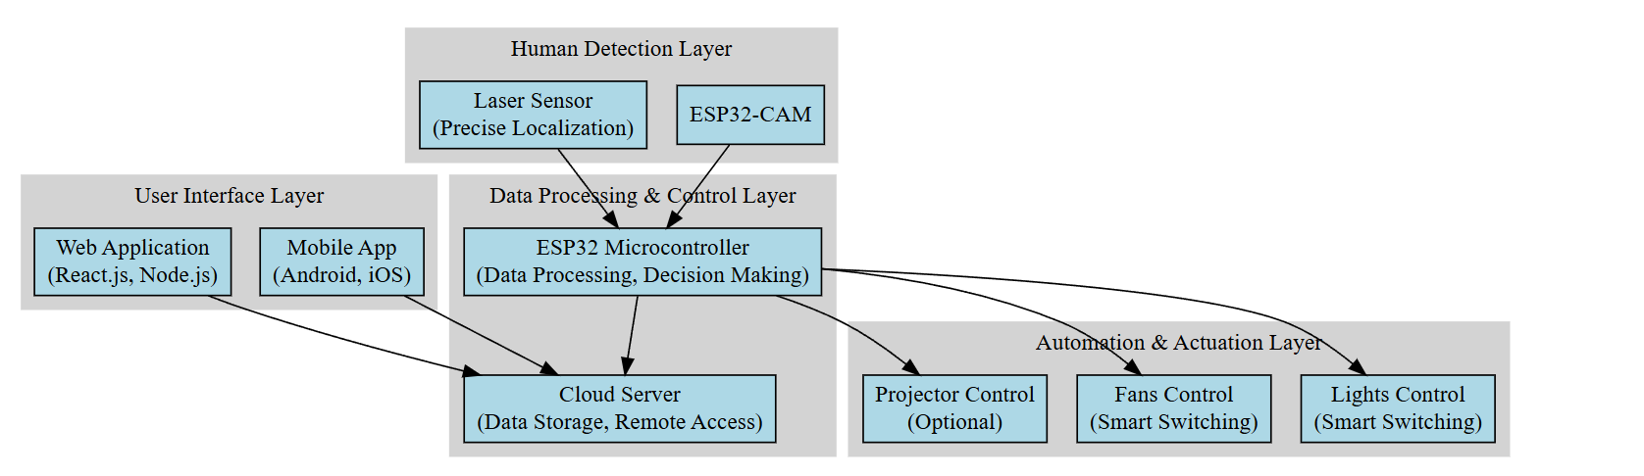

Figure 5.1 System Architecture Diagram

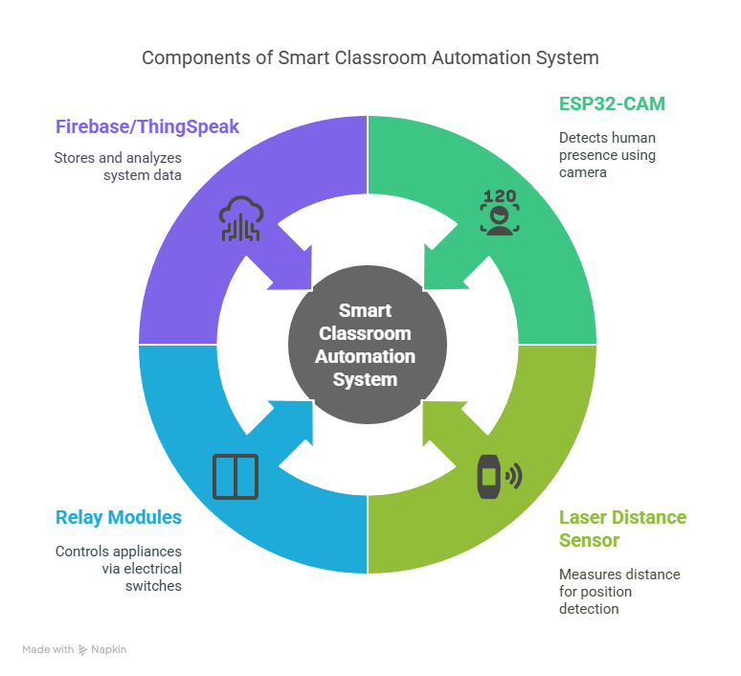

Figure 5.2 Data Flow Diagram

**UML Diagrams:**

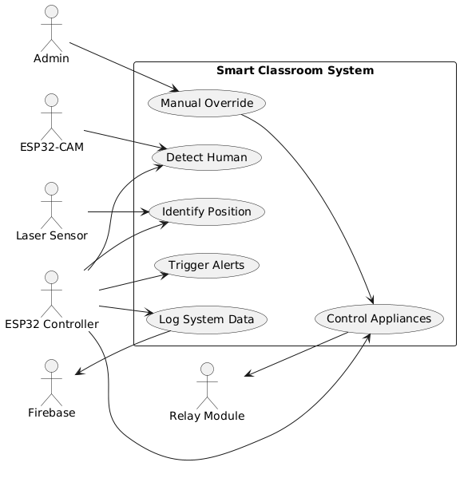

Figure 5.3.1 Use case Diagram

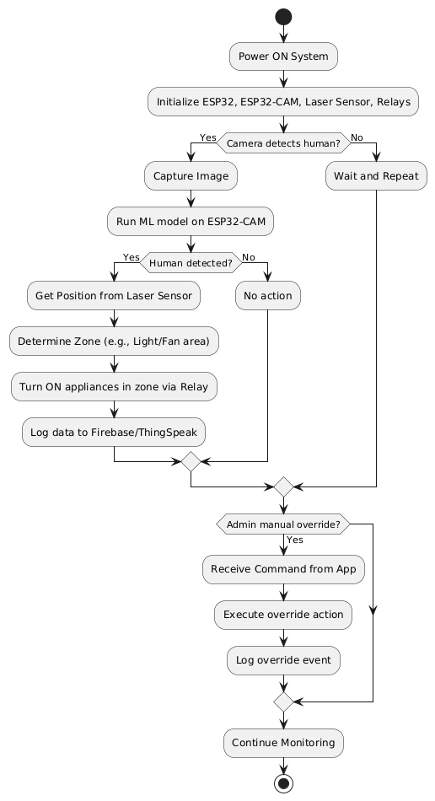

Figure 5.3.2 Activity Diagram

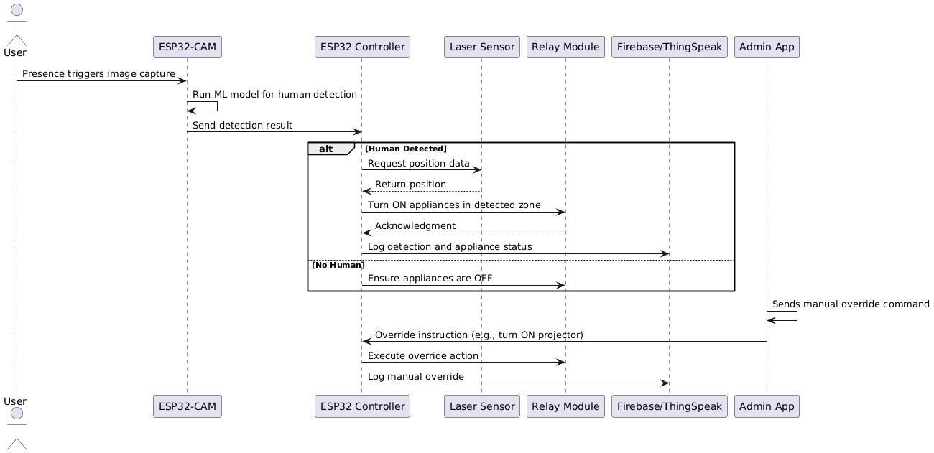

Figure 5.3.3 Sequence Diagram

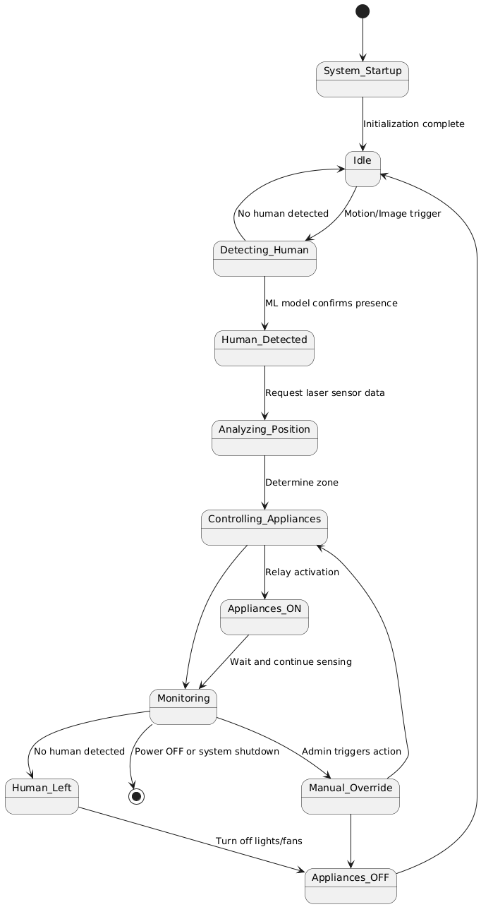

Figure 5.3.4 State Diagram

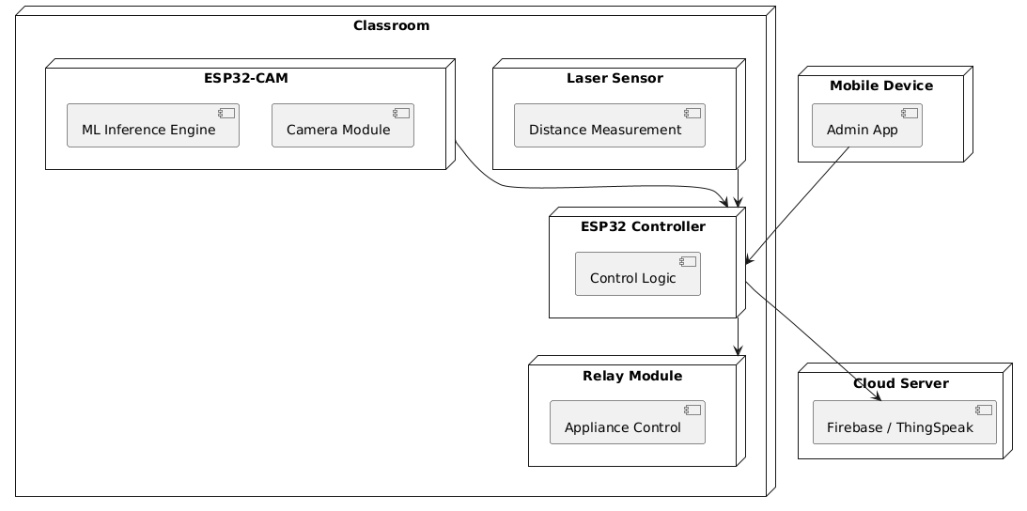

Figure 5.3.5 Deployment Diagram

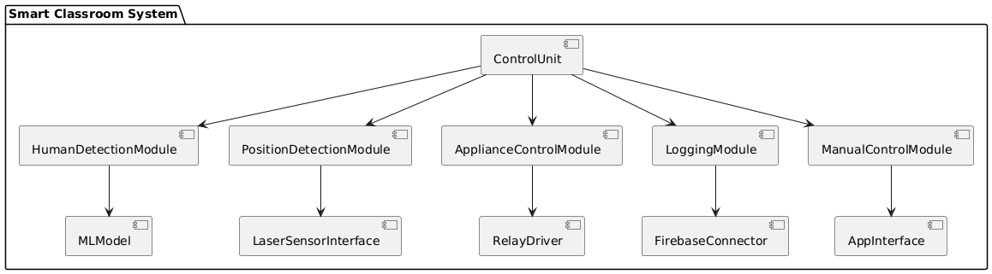

Figure 5.3.6 Component Diagram

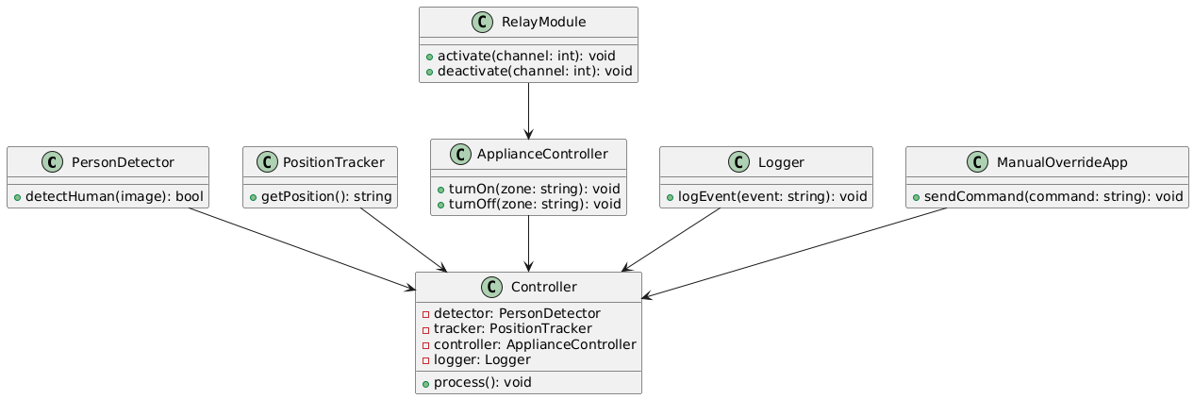

Figure 5.3.7 Class Diagram

**6. IMPLEMENTATION**

The system is implemented in several coordinated stages, integrating IoT hardware, deep learning models, and cloud-based control systems:

**1. Hardware Setup**

1. ESP32-CAM Installation:
   1. Positioned strategically in the classroom to capture a wide field of view.
   2. Connected to relay modules for device control.
2. ESP32 Microcontroller:
   1. Acts as the central controller.
   2. Interfaces with sensors (VL53L0X) and relays.
3. Laser Sensors (VL53L0X):
   1. Mounted at various zones in the classroom for accurate distance measurement.
   2. Determine user proximity and zone classification.
4. Relay Modules:
   1. Connected to lights, fans, or projectors.
   2. Controlled via ESP32 GPIOs to switch devices ON/OFF.

**2. Software Development**

1. Arduino IDE:
   1. Used for writing firmware for ESP32 and ESP32-CAM.
   2. Libraries for sensors, WiFi, camera, and relays are integrated.
2. Python + TensorFlow/Keras:
   1. Datasets of classroom environments are prepared.
   2. Human vs. non-human object detection model is trained.
   3. The model is optimized for edge deployment.
3. Edge Impulse:
   1. Trains, tests, and exports TinyML models optimized for ESP32-CAM.

**3. ML Model Deployment**

1. Human Detection Model:
   1. Deployed directly on the ESP32-CAM using model conversion tools.
   2. No need for constant cloud communication, saving bandwidth and latency.
2. Inference on Edge:
   1. ESP32-CAM detects human presence in real-time.
   2. The detection triggers the corresponding zone control logic.

**4. System Communication**

1. Data Transmission:
   1. ESP32 devices communicate using WiFi (e.g., to Firebase/ThingSpeak).
   2. Updates and logs are sent to the cloud or a local Node.js server.
2. User Interface (ReactJS):
   1. Offers real-time monitoring of device status and energy usage.
   2. Users can override automatic controls via app or voice.

**5. Energy Control Logic**

1. Occupancy-Based Switching:
   1. Human detected in Zone A → turn ON lights/fans in Zone A.
   2. No presence detected → all appliances OFF.
2. Dynamic Optimization:
   1. Based on time-of-day, occupancy level, and user settings.

**6.1 METHODOLOGY**

The methodology focuses on edge-based intelligence and IoT-based automation:

**1. Sensing Phase**

* ESP32-CAM continuously captures images.
* VL53L0X provides precise distance data.
* Input is collected without relying on cloud-based computations.

**2. Inference & Detection**

* The on-device ML model detects the presence of humans.
* Differentiates between humans and static objects.
* Prevents false triggers (e.g., due to bags, chairs).

**3. Zonal Analysis**

* Distance data from VL53L0X determines human location in the classroom.
* Zones are predefined and mapped to specific appliances.
* Example: Zone 1 → Light 1 and Fan 1.

**4. Decision Making**

1. The ESP32 Microcontroller decides:
   1. Which devices to activate.
   2. Which to keep turned OFF.
2. Logic includes fallback timers and priority zones.

5. **Execution**

* Relay modules receive instructions from the microcontroller.
* Lights, fans, and projectors are controlled accordingly.
* All switching is done through low-latency GPIO control.

**6. Feedback and Learning**

1. Optional Firebase/ThingSpeak stores:
   1. Logs of usage.
   2. Energy savings.
2. Data can be used for future model tuning and analytics.

**6.2 SYSTEM OVERVIEW**

The system architecture is modular and distributed, designed for scalability and responsiveness:

1. **Smart Classroom System (Central Unit)**

* Connects all sub-modules: sensors, AI model, relays, microcontrollers.
* Makes decisions in real-time.
* Communicates with the cloud and user interfaces.

1. **ESP32-CAM Module**

* Captures classroom images.
* Detects human presence using a deep learning model.
* Operates at the edge to reduce latency and network load.

1. **ESP32 Microcontroller**

* Collects sensor data from VL53L0X.
* Controls relays for appliances.
* Executes decisions from AI inference + sensor inputs.

1. **VL53L0X Laser Sensor**

* Measures how far a person is from the device.
* Used to infer which area of the classroom is occupied.

1. **Data Transmission Module**

* Syncs system logs and updates with:
  + Cloud platforms (e.g., Firebase).
  + Mobile app dashboards.

1. **User Input**

* Allows manual override via:
  + Mobile app (ReactJS frontend).
  + Voice control (if supported via assistant integration).

1. **Deep Learning Model**

* Trained on classroom images.
* Capable of identifying and tracking human presence in varied conditions (day/night, seated/standing).

1. **Energy Optimization Module**

* Reduces unnecessary energy consumption.
* Ensures devices are used only when needed.
* Tracks usage trends to adapt better over time.

1. **Alerts & Notifications**

* Sends:
  + Occupancy alerts.
  + Daily energy usage reports.

Useful for administrators and users to monitor system efficiency.

**7. PROJECT PLAN**

**Phases of Development**

| **Phase No.** | **Phase Title** | **Detailed Description** |
| --- | --- | --- |
| **1** | Problem Definition & Analysis | This phase involves identifying the problem of energy inefficiency in educational environments, particularly classrooms where fans and lights remain switched on regardless of human presence. The scope of the project was defined by exploring how smart automation and AI-based human detection can be employed to reduce energy wastage. The primary goal was set to automate the switching of electrical appliances using real-time occupancy data. |
| **2** | Requirements Gathering | The team conducted a feasibility study and identified the most suitable hardware and software components required to implement the solution. This included selecting the **ESP32-CAM** for image capture and ML inference, the **VL53L0X** laser sensor for distance measurement, and **relays** for device control. Additionally, **Edge Impulse** was chosen as the machine learning platform due to its compatibility with embedded devices. |
| **3** | Data Collection | To train an effective AI model, a dataset was created by capturing a variety of images using the ESP32-CAM. These included images of an empty classroom as well as images with students present. The dataset was prepared in different lighting and positional scenarios to make the model robust and adaptable to real-world conditions. |
| **4** | Model Training | Using Edge Impulse, a **tiny CNN (Convolutional Neural Network)** was trained to classify images into two categories: “Human Present” and “No Human.” The model was quantized to run efficiently on the limited memory of the ESP32-CAM. Several iterations of training and testing were performed to improve the accuracy and reduce false positives/negatives. |
| **5** | System Design | During this phase, the architecture of the entire system was designed. The ESP32-CAM was designated for image capture and AI inference, the VL53L0X sensor for real-time distance detection, and ESP32 GPIO pins were used to interface with relays controlling electrical appliances. The design also included zonal control logic, where only fans and lights near detected occupants would be activated. |
| **6** | Integration & Development | In this phase, all individual components were integrated. The trained model from Edge Impulse was deployed to the ESP32-CAM. The microcontroller was programmed using Arduino IDE to run inference on real-time video frames and make decisions based on model output. Relay modules were connected to control electrical loads based on detection and measured distance. |
| **7** | Testing & Validation | Rigorous testing was conducted in a real classroom setup. The model’s accuracy in detecting human presence was measured, and the distance-sensing logic was verified for correct zone-based operation. The energy-saving performance was evaluated by comparing energy consumption before and after deploying the system. |
| **8** | Optimization & Documentation | Based on the test results, thresholds for detection confidence and distance were fine-tuned to optimize system response. Code and logic were cleaned and organized for efficiency. Finally, the complete documentation including system diagrams, implementation steps, testing results, and future enhancement possibilities was prepared for submission. |

**7.2 Resource Allocation**

| **Component** | **Purpose and Utilization** |
| --- | --- |
| **ESP32-CAM** | Used as the primary sensing unit to capture images of the classroom and run the trained machine learning model locally. Its low cost and built-in camera make it ideal for edge-based AI inference without needing a server or cloud processing. |
| **VL53L0X Laser Sensor** | A time-of-flight sensor used to accurately measure the distance between the detected human and the device. This distance is used to determine the zone of the classroom and accordingly activate or deactivate lights and fans in that zone. |
| **Relay Modules** | Connected to the ESP32's GPIO pins, these relays serve as electronic switches to control classroom electrical appliances (fans, lights) based on the system’s decisions. |
| **Edge Impulse** | A cloud-based machine learning platform used to train, test, and export the human detection model in a format compatible with ESP32. It simplifies the process of deploying machine learning on embedded devices. |
| **Arduino IDE** | The development environment used to program both the ESP32 and ESP32-CAM microcontrollers. It facilitates code compilation, uploading, and debugging. It also supports integration with various libraries such as those for Edge Impulse, VL53L0X, and relays. |

**8.Conclusion**

This project presents an innovative solution for energy optimization in smart classrooms using low-cost embedded hardware and machine learning on edge devices. By integrating ESP32-CAM with a lightweight AI model trained via Edge Impulse, the system can accurately detect human presence in real-time. Combined with the VL53L0X laser distance sensor, the solution allows zone-based control of lights and fans, thereby reducing unnecessary energy consumption.

The successful deployment of this system contributes to:

* Energy-efficient infrastructure
* Reduced manual intervention
* Scalable smart automation

Future enhancements could include attendance monitoring, voice assistant integration, or mobile app control. This project demonstrates how IoT and AI can be combined effectively to build sustainable, intelligent environments that align with modern educational and energy-saving goals.

**9. Reference**:

**Research Papers on IoT-Based Energy Optimization in Classrooms:**

1.An IoT-Based Energy Conservation Smart Classroom System This paper discusses the design and implementation of an IoT-based system for energy conservation in classrooms, focusing on real-time control and monitoring of devices like lights and air conditioners. (<https://www.researchgate.net/publication/362806572_An_IoT-Based_Energy_Conservation_Smart_Classroom_System>)

2.Smart Energy Management in Classroom using IoT Explores how machine learning-based IoT systems can analyze energy consumption patterns and adjust power usage in educational settings. (https://www.researchgate.net/publication/368940902_Smart_Energy_Management_in_Classroom_using_IoT)

3.Energy Conservation Smart Classroom System using IoT Presents a cost-effective IoT-based device control system aimed at reducing energy consumption in classrooms. [Read the paper] (<https://www.scienceimpactpub.com/journals/index.php/IJAM/article/download/546/283/3125>)

4.IoT-Based Energy Efficient Smart Classroom Describes a smart classroom system where electrical appliances are automated with a focus on energy conservation by dividing the classroom into zones. (<https://www.researchgate.net/publication/348149991_IoT_Based_Energy_Efficient_Smart_Classroom>)

5.Automation of IoT-Based Classroom: Integrating Light, Fan Introduces an innovative IoT-based automation framework designed specifically for classroom environments to optimize energy usage. (<https://www.irjmets.com/uploadedfiles/paper//issue_5_may_2024/56136/final/fin_irjmets1716046285.pdf>)

6.Energy Smart Saving Classroom with IoT Based Discusses a smart lecture room system that controls access and energy usage using IoT technologies. (<https://www.researchgate.net/publication/345333023_Energy_smart_saving_classroom_with_IoT_based>)

7.Classroom Light and Fan Automation Focuses on automating lighting and fan systems in classrooms using IoT to enhance energy efficiency. (<https://www.researchgate.net/publication/366965295_Classroom_Light_and_Fan_Automation/download>)

8.Automated Light Control for IoT Application Presents a practical implementation of IoT in daily activities, focusing on automated light control to reduce energy consumption. (<https://www.researchgate.net/publication/371827112_Automated_Light_Control_for_IoT_Application>)

9.IoT-Based Smart Classroom Automation System Details an IoT-based system enabling real-time monitoring and control of electrical appliances in classrooms. (<https://ijariie.com/AdminUploadPdf/IoT__Based_Smart_Classroom_Automation_System_ijariie26185.pdf>)

10.IoT-Based Smart Classroom Explores the integration of IoT in classrooms for dynamic booking and control of lights and fans using mobile applications. (<https://www.researchgate.net/publication/352570013_IoT_Based_Smart_Classroom>)

**Research on Human Presence Detection and Occupancy Monitoring**

11.Edge-Based Transfer Learning for Classroom Occupancy Detection Proposes an approach for people counting using cameras and Raspberry Pi platforms, beneficial for occupancy detection in classrooms. <https://www.mdpi.com/1424-8220/22/10/3692>)

12.IoT-Based Occupancy Detection System in Indoor Residential Presents an IoT-based occupancy detection system using changes in dust concentration patterns, which can be adapted for classroom environments. (https://www.sciencedirect.com/science/article/abs/pii/S0360132318300611)

13.Occupancy Monitoring with IoT Sensors Discusses how occupancy sensors provide real-time visibility on room utilization, aiding in energy optimization.

(https://www.iotforall.com/occupancy-monitoring-with-iot-sensors)

14.ESP32-CAM Object Detection with Edge Impulse Demonstrates how to use Edge Impulse to train an ESP32-CAM for object detection, useful for detecting human presence in classrooms. (<https://dronebotworkshop.com/esp32-object-detect/>)

15.LD2410 Sensor with ESP32 - Human Presence Detection A tutorial on interfacing the LD2410 sensor with ESP32 for human presence detection, which can be applied in classroom settings. (https://how2electronics.com/ld2410-sensor-with-esp32-human-presence-detection/)

**Studies on Energy Optimization and Smart Building Integration**

16.Improving Energy Efficiency in Buildings with an IoT-Based Smart Monitoring System Presents a real-time IoT-based smart monitoring system designed to optimize energy consumption and enhance safety. (<https://www.mdpi.com/1996-1073/18/5/1269>)

17.IoT-Based Comfort Control and Fault Diagnostics System for Energy-Efficient Homes Explores a cost-effective smart home system that can be adapted for classroom energy optimization. (https://www.nrel.gov/docs/fy24osti/85920.pdf)

18.Occupancy Prediction in IoT-Enabled Smart Buildings Critically examines technologies for predicting occupant behavior, which is essential for energy optimization. (https://www.ncbi.nlm.nih.gov/pmc/articles/PMC11174554/)

19.IoT-Based Occupancy Monitoring Techniques for Energy-Efficient Smart Buildings Surveys existing works on occupancy monitoring and multi-modal data fusion techniques for smart buildings. (https://www.researchgate.net/publication/280157569_IoT-based_Occupancy_Monitoring_Techniques_for_Energy-Efficient_Smart_Buildings)

20.A Methodology for Saving Energy in Educational Buildings Using an IoT Infrastructure Discusses a methodology for achieving energy savings in schools based on IoT infrastructure. (https://arxiv.org/abs/1907.07760)

**Technical Resources and Implementation Guides:**

21.ESP32-CAM Video Streaming Web Server A guide on building an IP surveillance camera with the ESP32-CAM, useful for real-time monitoring. (<https://randomnerdtutorials.com/esp32-cam-video-streaming-web-server-camera-home-assistant/>)

22.Creating a Smart Home Security System with ESP32-CAM Details the setup of a smart home security system using ESP32-CAM, which can be adapted for classroom monitoring. (https://medium.com/@przyczynski/creating-a-smart-home-security-system-with-esp32-cam-detecting-people-and-notifying-via-onesignal-907f13246e18)

23.Millimeter Wave Presence Sensors With ESP32 Explains how to connect millimeter wave presence sensors to an ESP32 for human presence detection. (https://www.instructables.com/Millimeter-Wave-Presence-Sensors-With-ESP32/)

24.ESP32-CAM Motion Sensor Security Camera Focuses on designing a motion-activated security camera system using ESP32-CAM, applicable for occupancy detection. (<https://www.irjmets.com/uploadedfiles/paper//issue_12_december_2023/47001/final/fin_irjmets1701871777.pdf>)

25.BLE Human Presence Detector using an ESP32 A video tutorial on building a BLE-based human presence detector with ESP32, useful for energy optimization systems. (https://www.youtube.com/watch?v=KNoFdKgvskU)